**Probability distributions**

**Definition**

Cumulative - increasing by successive additions, accumulated part

Cumulative frequency – used to determine the number of observations that lie above (or below) a particular value in a data set. Calculated using frequency distribution table and adding each frequency from a frequency distribution table to the sum of its predecessors. The last value is always equal to all observations.

Cumulative distribution function – gives the probability that a value X is less than or equal to x. P(X<x).

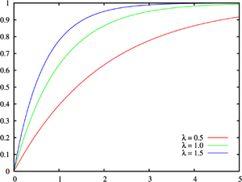

Figure 1: Cumulative distribution function for exponential distribution (wiki)

Uniform distribution – symmetric probability distributions. Easily dividable, with coin-flip (50-50) and dice (1/6). A straight line

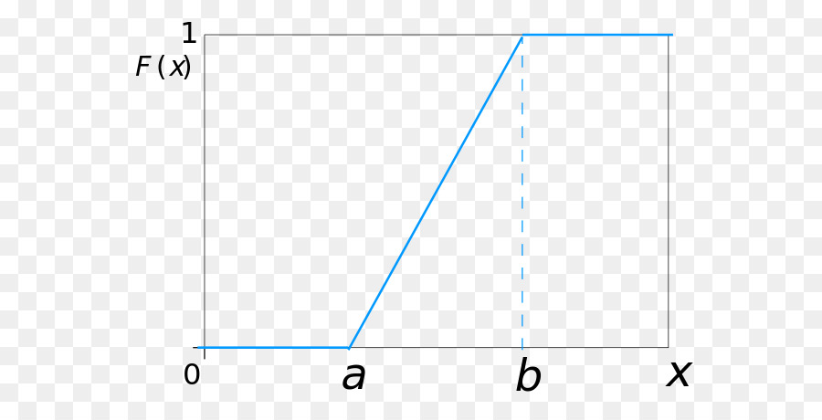

Normal distribution – bell shaped, symmetric around center.

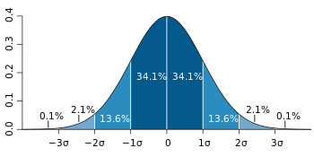

Chi-squared distribuation –

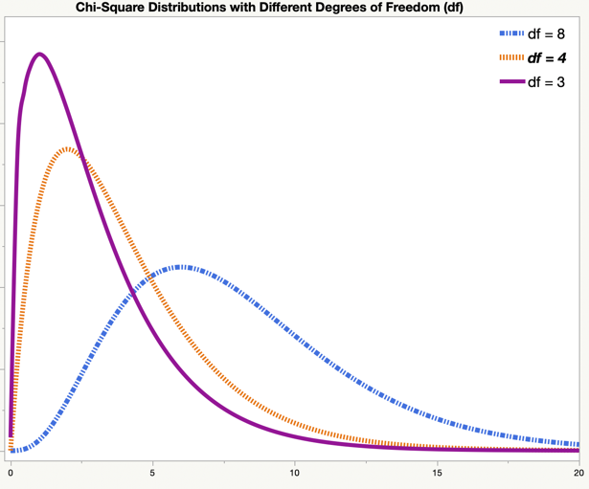

Power law

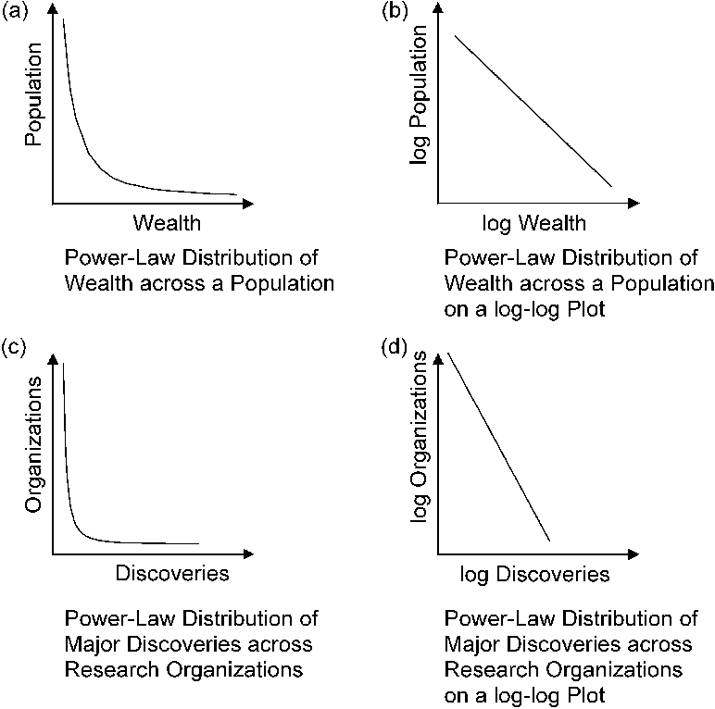

Poisson